



**EXECUTIVE SUMMARY:**

* The Bank Risk Controller System leverages advanced Machine Learning (ML) techniques to evaluate and predict financial risk within a banking environment.
* By analyzing historical transaction data, customer profiles, and external factors, the system aims to identify potential high-risk customers and prevent fraud.
* This project uses various ML models, including Random Forest, XGBoost, and Logistic Regression, to build a predictive framework for assessing the likelihood of defaults or fraudulent activity.
* The results of this analysis demonstrate significant improvements in risk prediction accuracy compared to traditional methods, providing a valuable tool for proactive risk management.

**PROBLEM STATEMENT EXPLAINATION:**

**Banks and financial institutions face a big challenge:**

How to decide whether a customer applying for a loan will pay it back or fail to do so (default). If customers default on their loans, it can lead to financial losses for the bank. Predicting which customers are likely to default is important for making smarter loan approval decisions and reducing risks.

The goal of this project is to create a machine learning model that analyzes past loan data and predicts whether a new customer will default or not. The prediction is based on information like the customer’s income, loan amount, credit history, and other details. The target column in the dataset is called **“TARGET”**, where:

* **1** means the customer defaulted (did not repay the loan).
* **0** means the customer successfully repaid the loan.

**FLOWCHART:**

* Data Collection
* Data Preprocessing
* Feature Engineering
* Model Training
* Model Evaluation
* Deployment

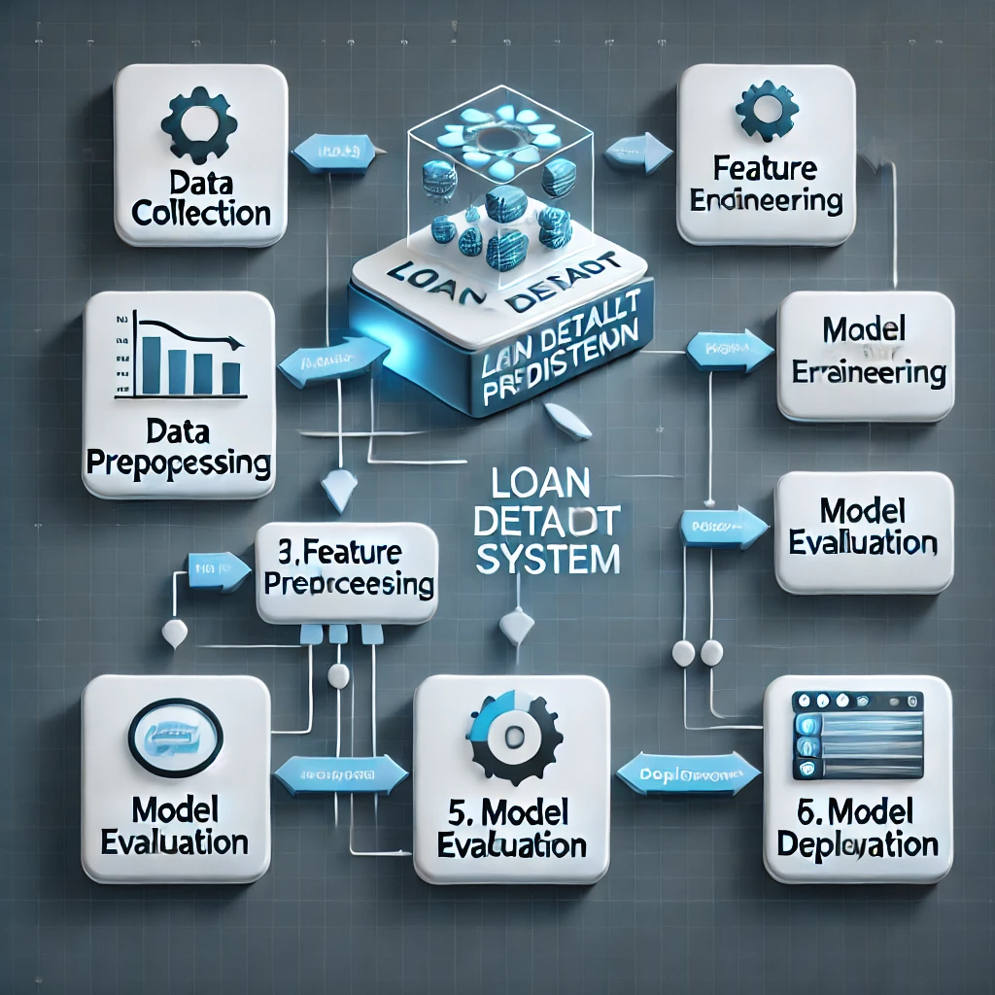

**APPROACH:**

DATA COLLECTION

The dataset used for this analysis contains comprehensive information related to historical loan records and customer details. It is a robust dataset suitable for building predictive models.

|  |  |  |
| --- | --- | --- |
| S.NO | ASPECT | DETAILS |
| 1 | Total Records | 14,13,701 |
| 2 | Total Features | 158 |
| 3 | Data Format | CSV |
| 4 | Usage Purpose | Predict loan default probabilities |
| 5 | Data Source | GUVI |
| 6 | Nature of the Dataset | Mix of Continuous and Categorical variables relevant to the financial domain |

DATA PRE-PROCESSING

TARGET COLUMN ANALYZING

* The data has

Target = 0 for people who can repay the loan and

Target = 1 for people who cannot repay loan. The data is imbalanced.

TARGET

0 1291341

1 122360

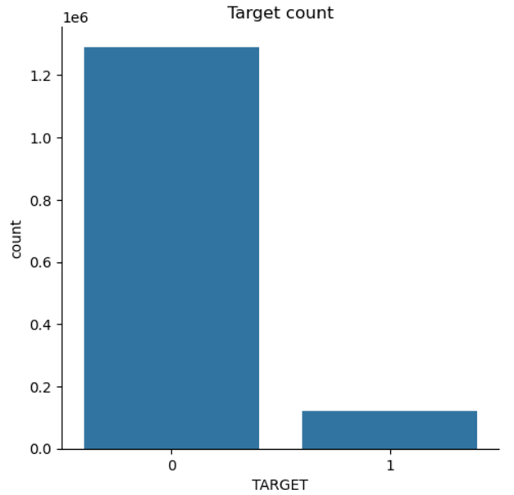

CASE SCENARIOS

(Scenario 1) - If the model has predicted client will repay loan but actually, he has defaulted.

(Scenario 2) - If the model has predicted client will default but he can actually pay loan back.

* But the loss will be much more in Scenario 1 i.e. If the model has predicted client will repay loan but actually, he has defaulted.
* Accuracy cannot be used for imbalanced data, hence not helpful in our case. Precision will tell of all the points that are predicted to be positive how many of them are actually positive. Precision doesn't consider, the points that were actually positive and are predicted positive.
* Recall is important since it will tell of all the points that are actually positive how many of them are predicted positive. So recall is important to identify the Scenario 1. If recall is high means defaulters are correctly predicted as defaulters
* F1-score is geometric mean of precision and recall and precision and is high if recall and precision are high. Since we have no use of precision here, F1-score or micro F1-score or macro F1-score is not important.
* In ROC-AUC score we have True Positive Rate and False Positive Rate; True Positive Rate is same as Recall so Scenario 1 gets covered. False Positive Rate is out of all the points that are actually negative how many are predicted as positive Scenario 2.
* Hence ROC-AUC score is an important metric since it covers both scenarios where Credit can suffer loss. ROC-AUC score should be greater than 0.5 which means your model is doing something right.

CODE_BASE FLOW

* 1. HANDLING MISSING VALUES



**Goal**: Ensure your dataset is complete and free of missing values, as they can skew or prevent accurate model building.

**Imputation**: Replace missing values using statistical techniques (mean, median, mode)

**Removal**: For columns with excessive missing data, consider dropping them.

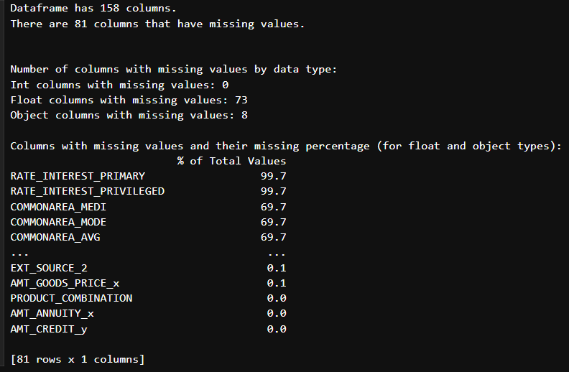

* 1. PRE-PROCESSING THE CATEGORICAL COLUMNS– IMPUATION TECHNIQUES
  2. PRE-PROCESSING THE NUMERICAL COLUMNS– IMPUATION TECHNIQUES

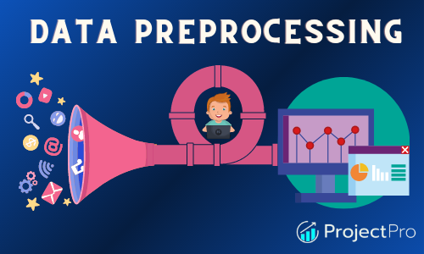

**Goal**: Handle categorical variables and numerical columns which may include missing data or require transformation for better model understanding.

**Imputation**: Replace missing categories with the mode (most frequent value), or use advanced techniques like KNN imputation for categorical variables.

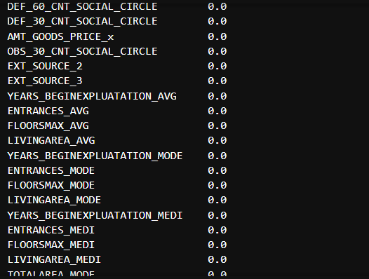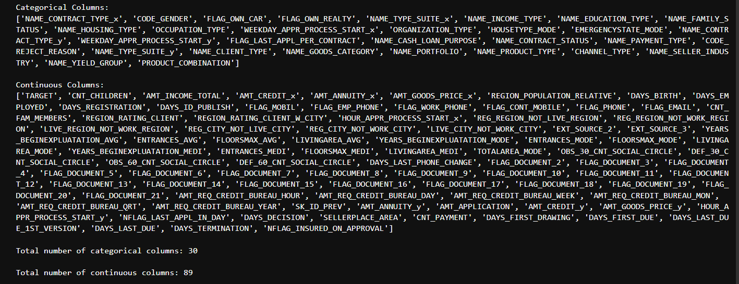

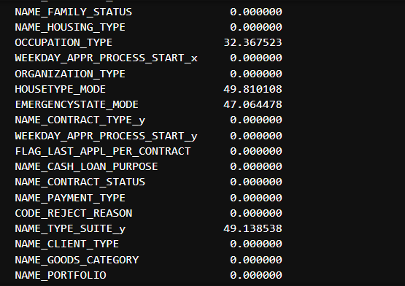

* 1. CHECK FOR DUPLICATES

**Goal**: Remove duplicate rows to avoid biasing the model with repeated data.

**Detection**: Identify duplicate rows based on feature values.

**Removal**: Drop exact duplicates while maintaining relevant data for training.

* 1. FEATURE ENGINEERING – TO REDUE THE SIZE OF THE COLUMNS



**Goal**: Create new features or modify existing ones to improve model performance and reduce dimensionality.

**Feature Creation**: Derive new features from existing ones (e.g., ratio features, interaction features).

**Feature Selection**: Drop irrelevant or redundant features.

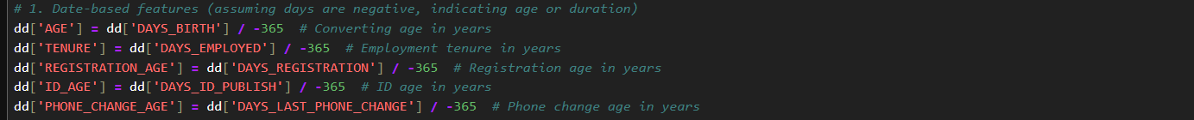

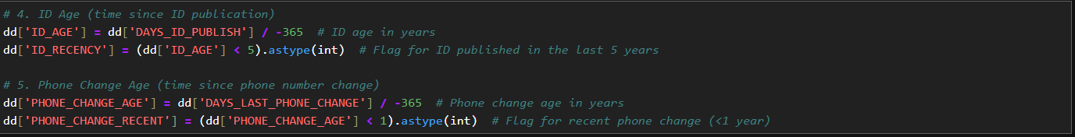







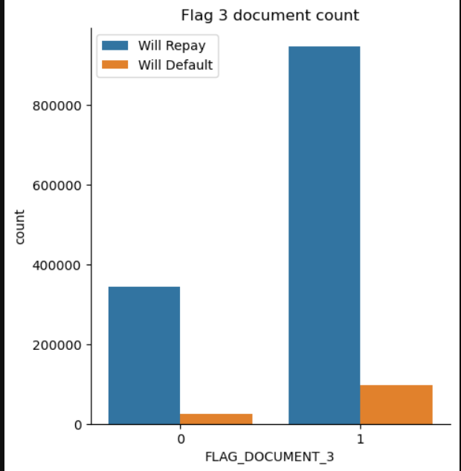

#Both type of clients mostly submits only 1 document which is document 3.

#FLAG_DOCUMENT_3 is the most common document submitted by the applicants.

#FLAG_DOCUMENT_3 is mostly submitted by the clients who can repay the loan and not submitted by the clients who cannot repay the loan but this could be also possible because the data is imbalanced.

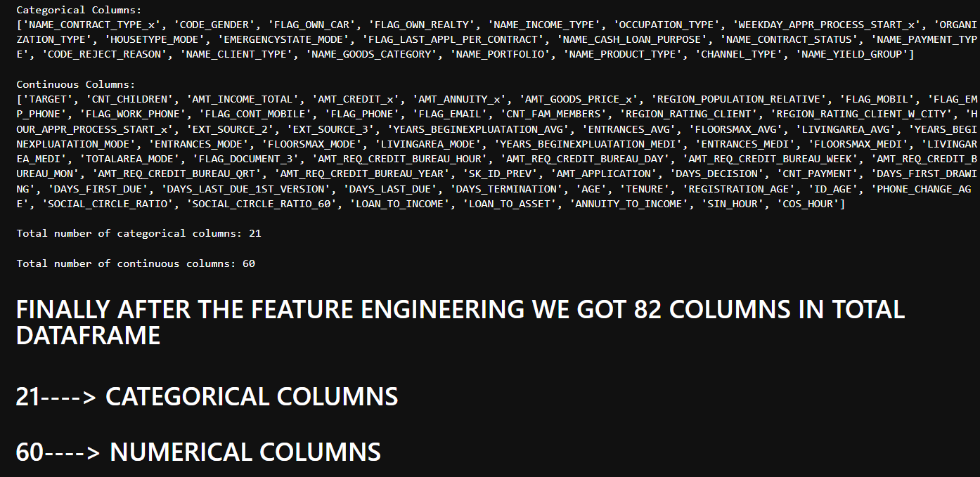

* 1. HEATMAP CORRELATION
  2. DROP FEATURES WHICH ARE NOT HIGHLY CORRELATED WITH THE TARGET COLUMN

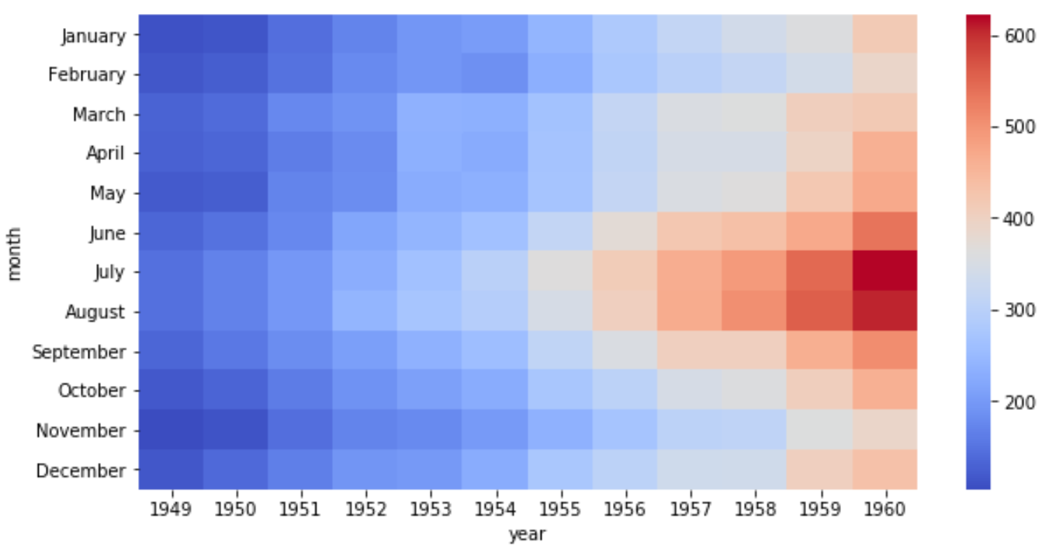

**Goal**: Visualize the relationships between features and identify correlations.

**Correlation Matrix**: Generate a heatmap to display correlation coefficients between numerical features.

**Insights:** Look for strong correlations between features and the target variable to identify important predictors.

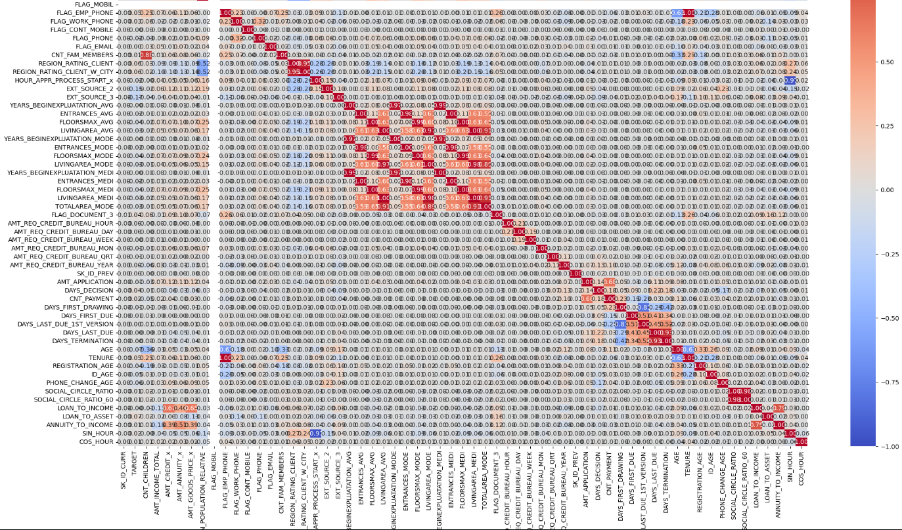

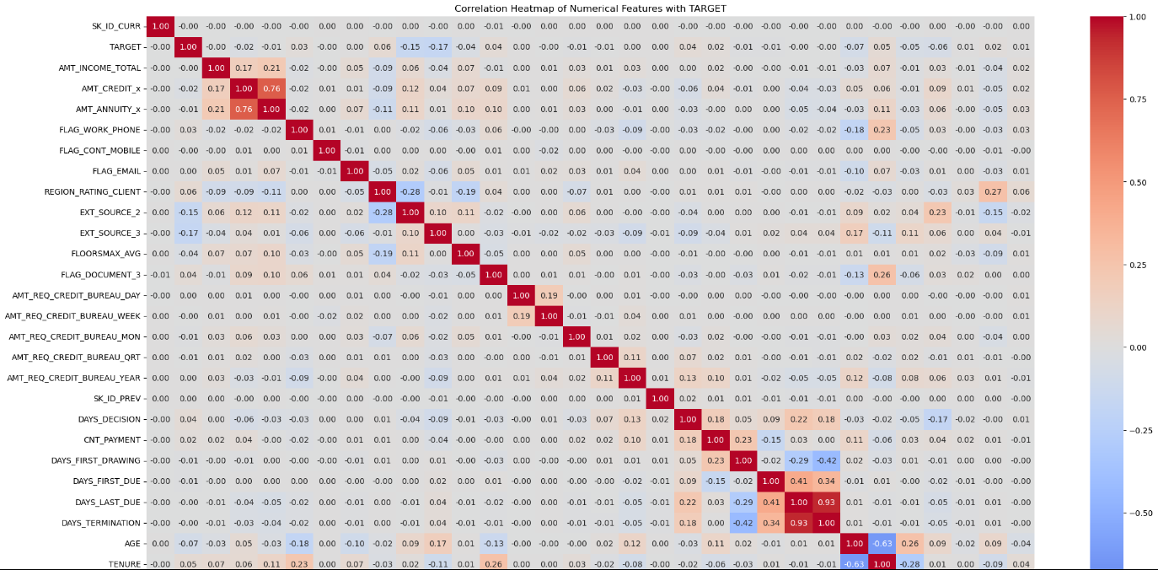

* 1. ENCODING

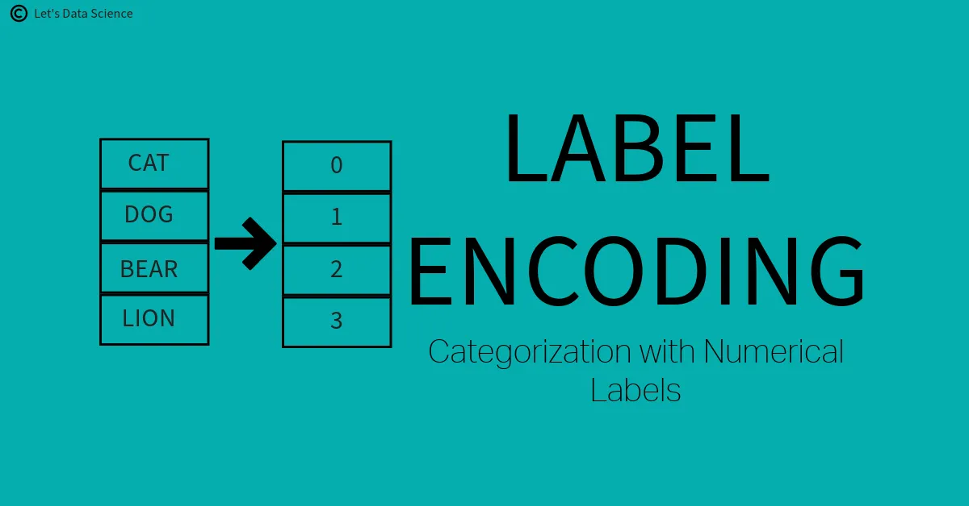

**Goal**: Convert categorical features into a numerical format suitable for machine learning models.

**Label Encoding**: Assign integer values to categories.

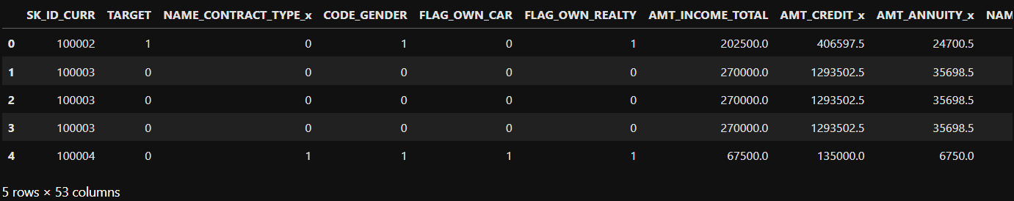

* 1. TREATING OUTLIERS

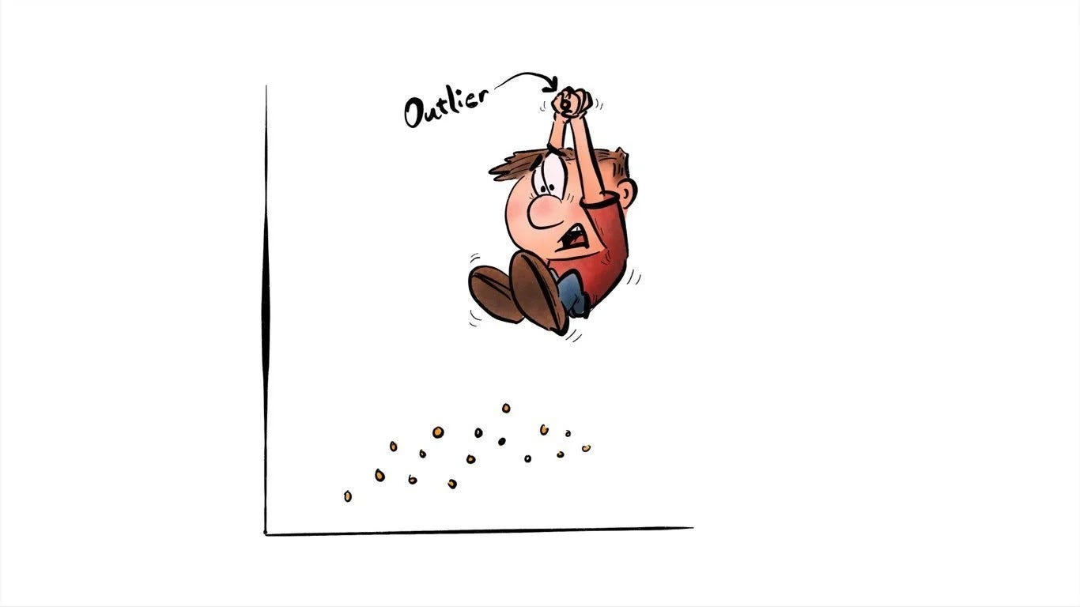

**Goal**: Identify and handle outliers that can distort statistical analysis and model training.

**Detection**: Use statistical techniques (IQR) to identify outliers.

**Handling**: Cap, transform, or remove outliers based on their impact on the model’s performance.

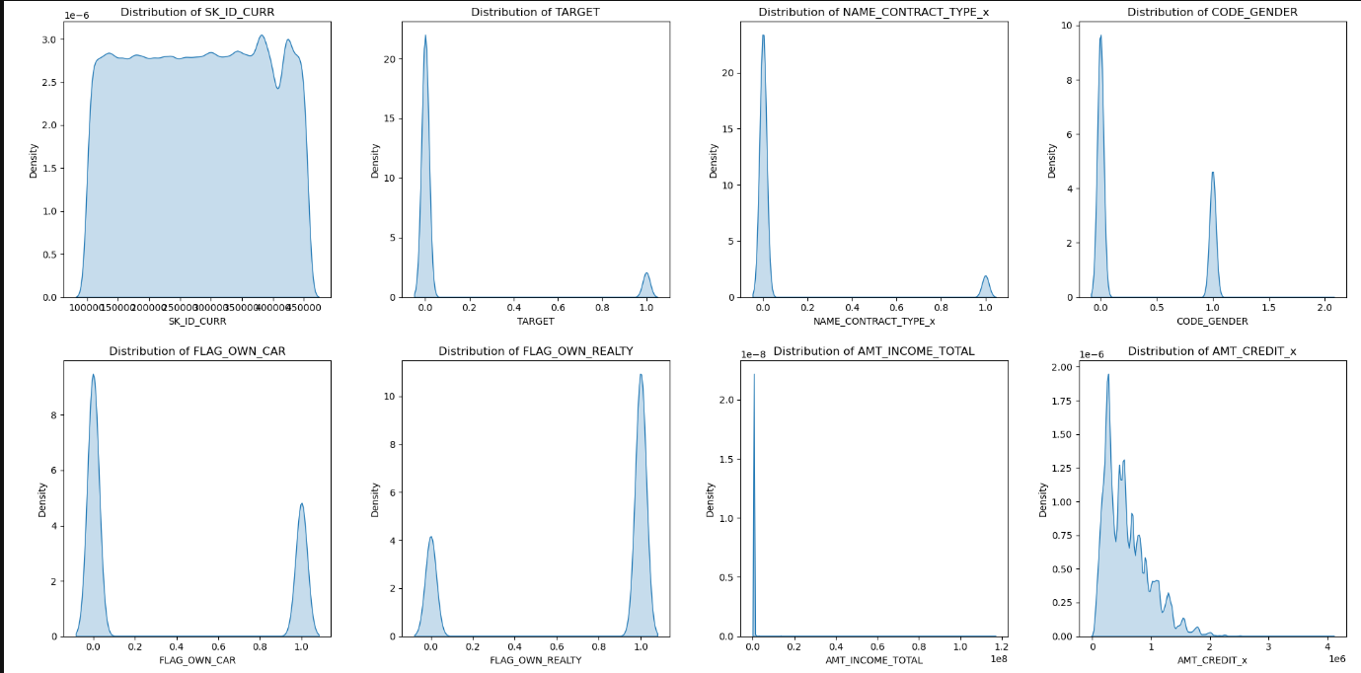

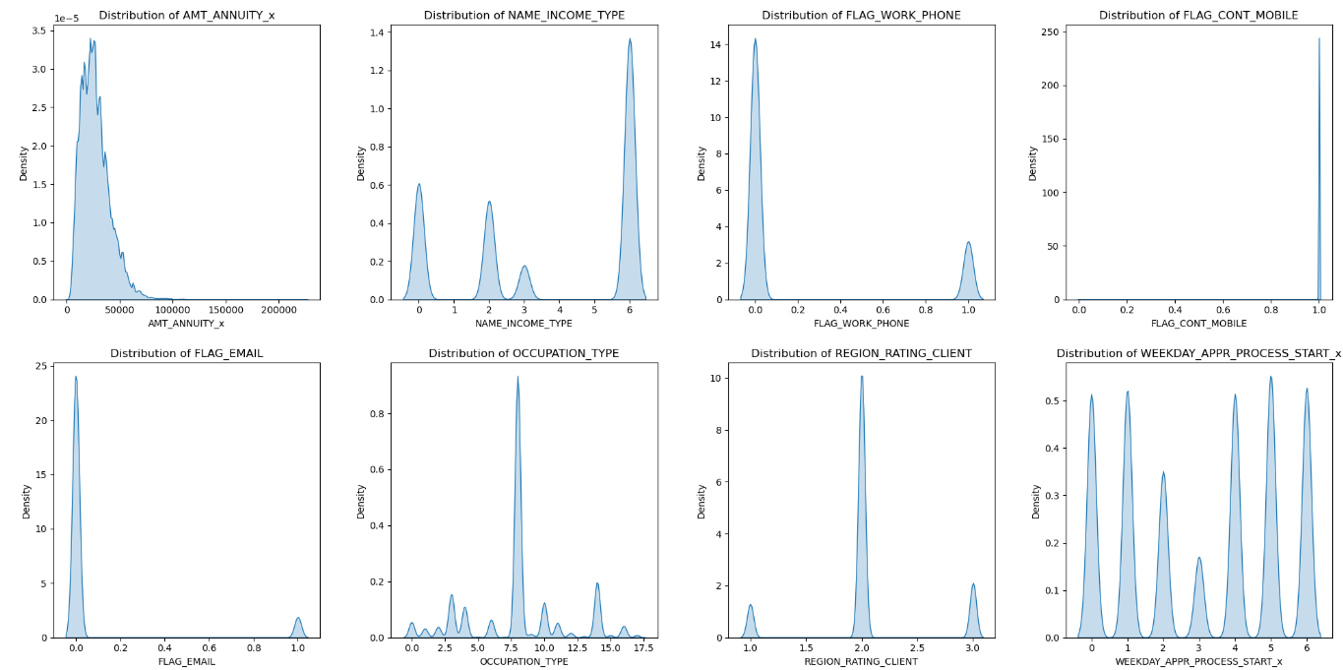

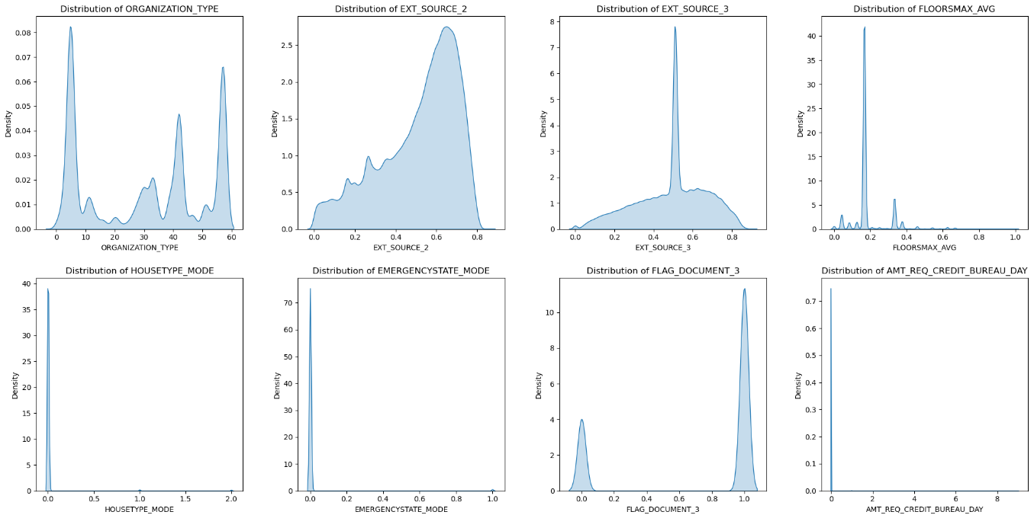

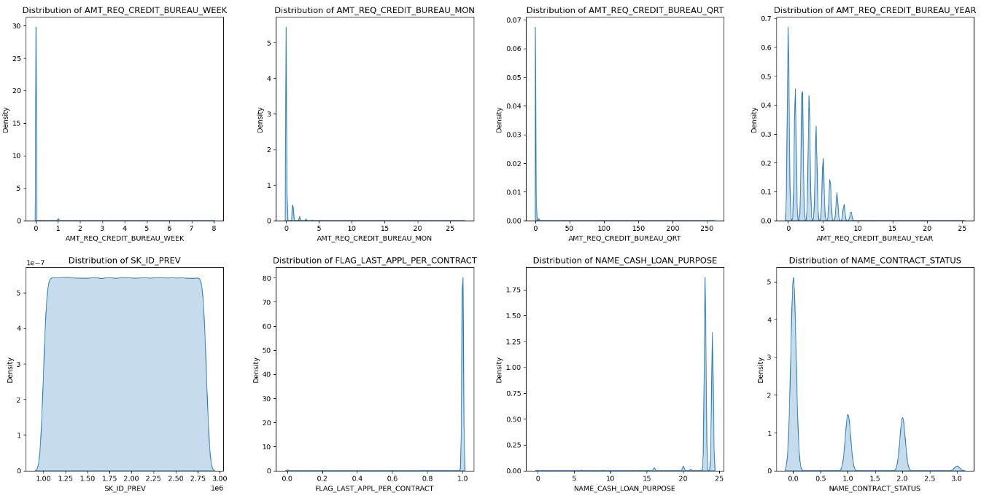

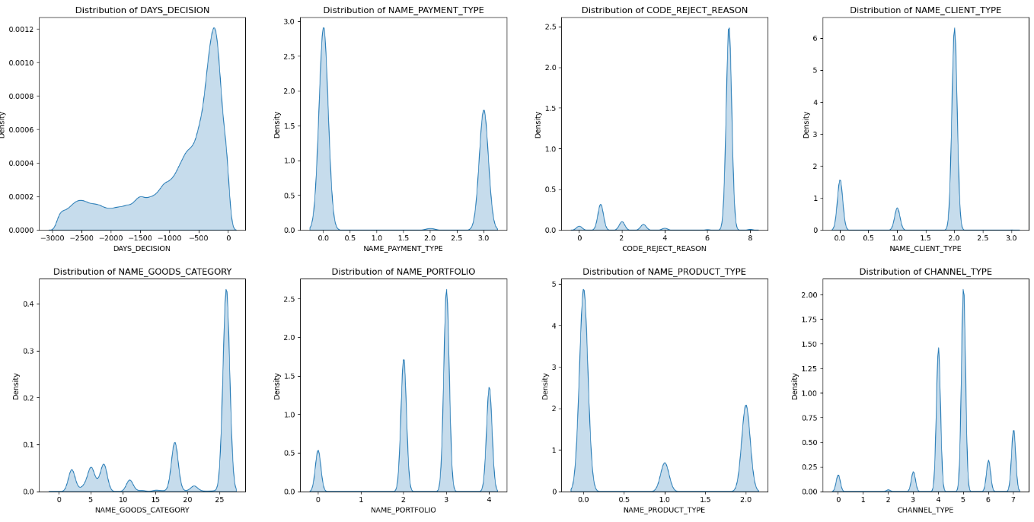

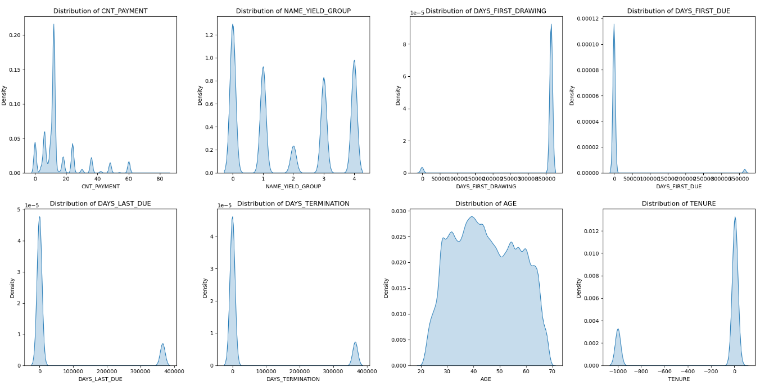

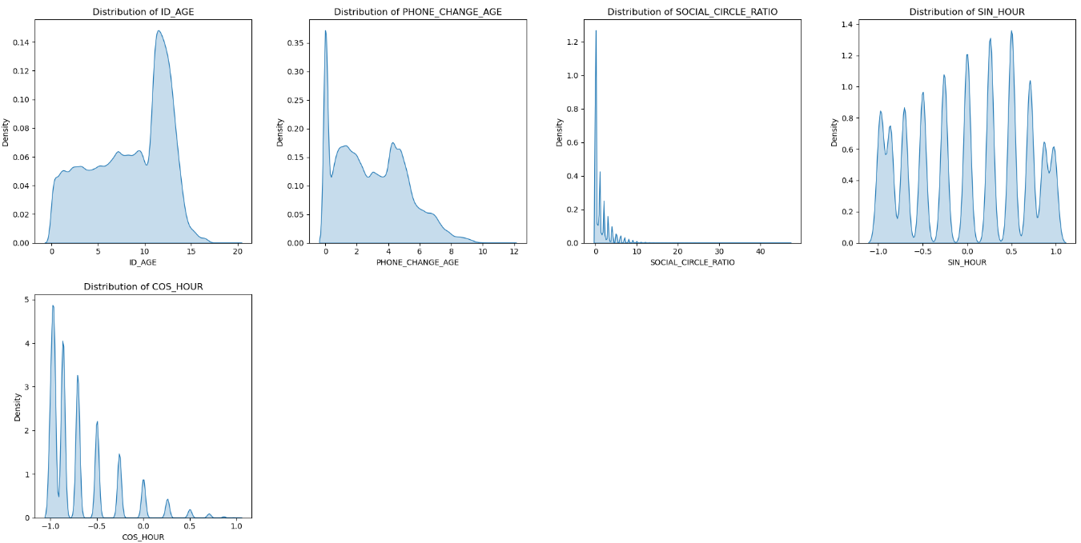

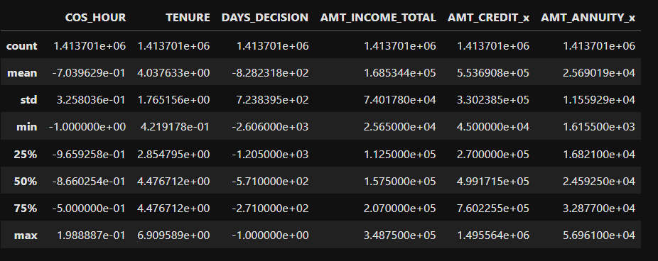

* 1. DO THE HEATMAP 🡪 TO EXTRACT THE COLUMNS
  2. SAVE THE FINAL FILE FOR MODEL

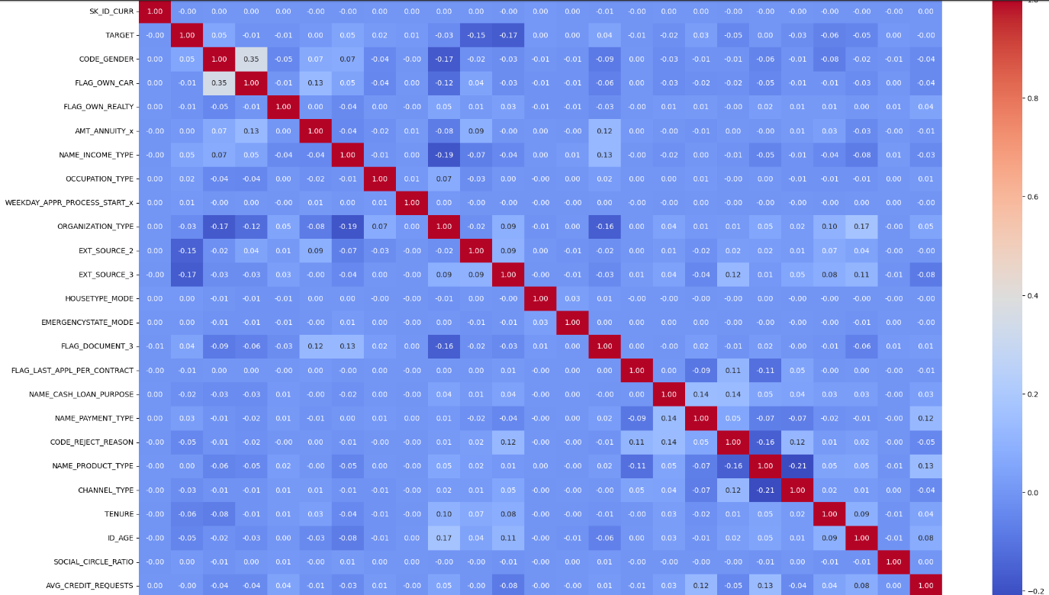

**Goal**: Visualize feature relationships after treating outliers and perform feature extraction.

**Post-Outlier Analysis:** Create a new heatmap after handling outliers to reassess the correlation matrix.

**Column Extraction**: Focus on columns with the highest correlation with the target.

**Goal**: Store the cleaned and processed dataset for model training.

**Export**: Save the dataset in a suitable format (CSV, Excel, etc.) to be used in training the machine learning model.

* 1. DID THE FS_IMPORTANCE AND SCORE RESPECT TO THE TARGET COLUMN

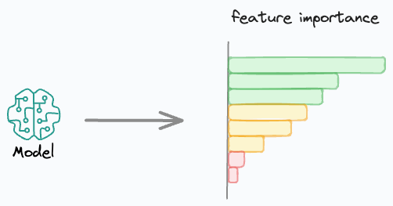

**Goal:** Evaluate the importance of features in predicting the target.

**Feature Importance**: Use models like Random Forest or statistical tests to assess which features contribute most to the prediction.

**Selection**: Retain the most significant features and drop less important ones.

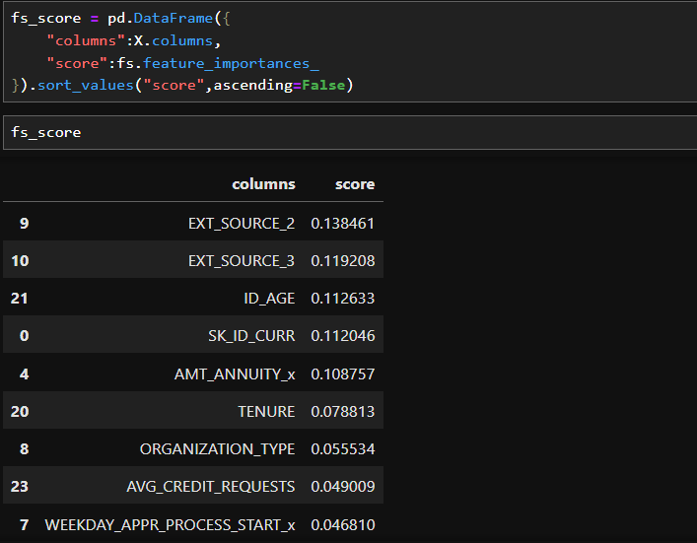

* 1. DID THE SMOTE 🡪 TO CORRECT THE CLASS IMBALNCE



**Goal:** Address class imbalance by oversampling the minority class.

**SMOTE** (Synthetic Minority Over-sampling Technique): Generate synthetic data points for the minority class to balance the dataset.

**Evaluation**: Ensure the balance does not introduce noise or overfitting.

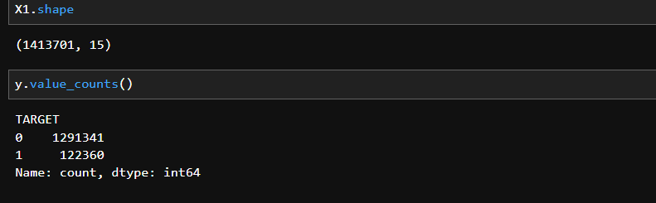

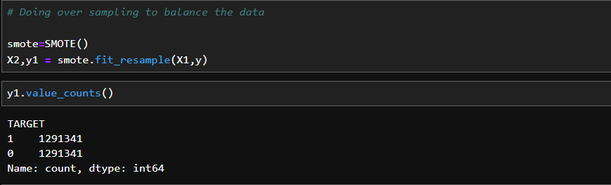

* 1. TRAIN-TEST SPLIT
  2. MODEL BUILDING

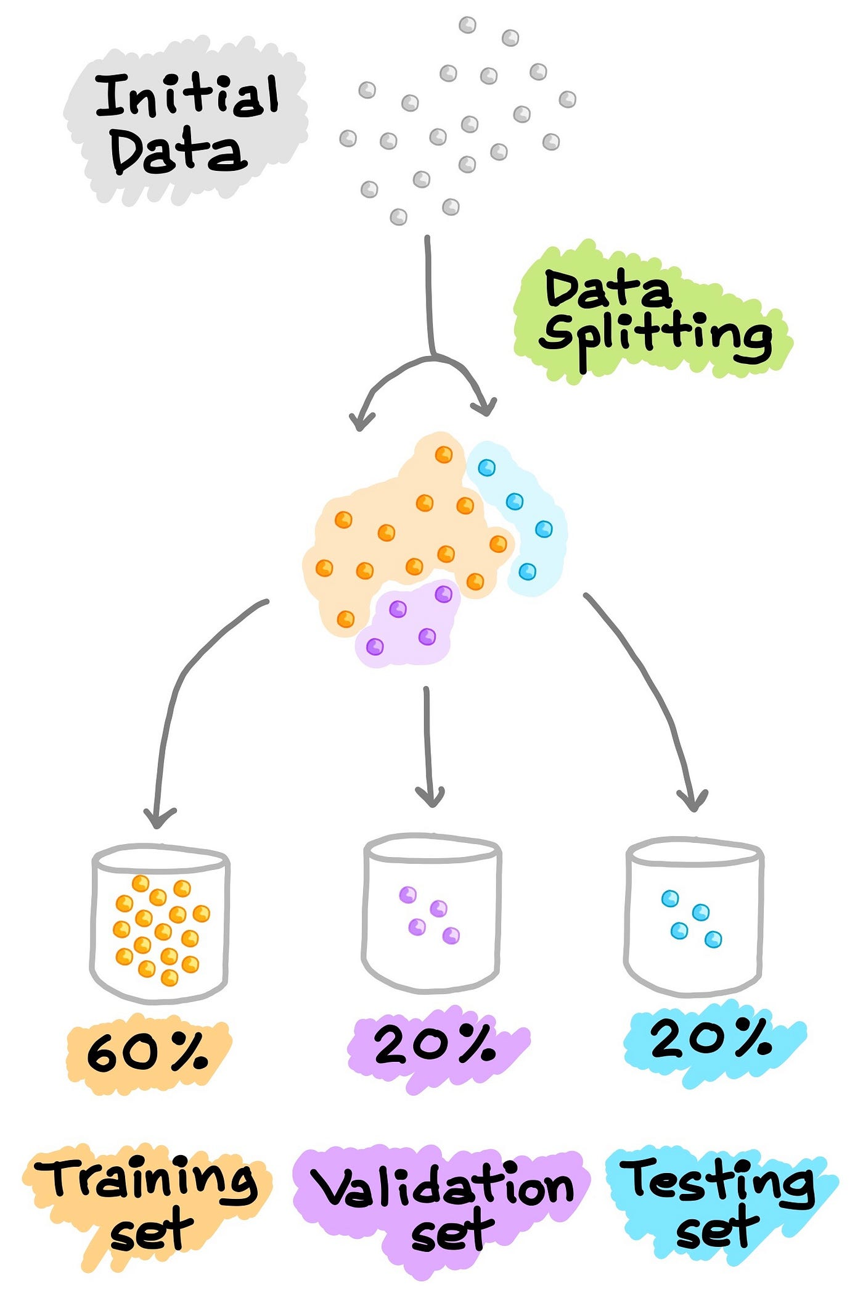

**Goal**: Divide the dataset into training and testing subsets to evaluate model performance.

Train machine learning models to predict the target variable.

**Split Ratio**: Use standard splits like 80/20 for training and testing data.

**Stratified Split**: Ensure that the split maintains class distribution, especially for imbalanced datasets.

**Algorithm Selection**: Choose appropriate algorithms based on the problem type (classification, regression) and dataset.

**Model Tuning:** Tune hyperparameters using techniques like XG Booster or Random Search to optimize performance.

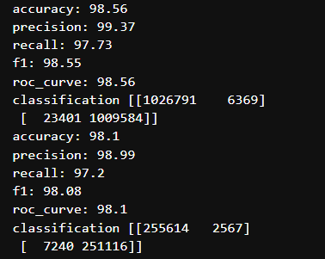

BEST MODEL IS **EXTREME GRAIDENT BOOSTING**

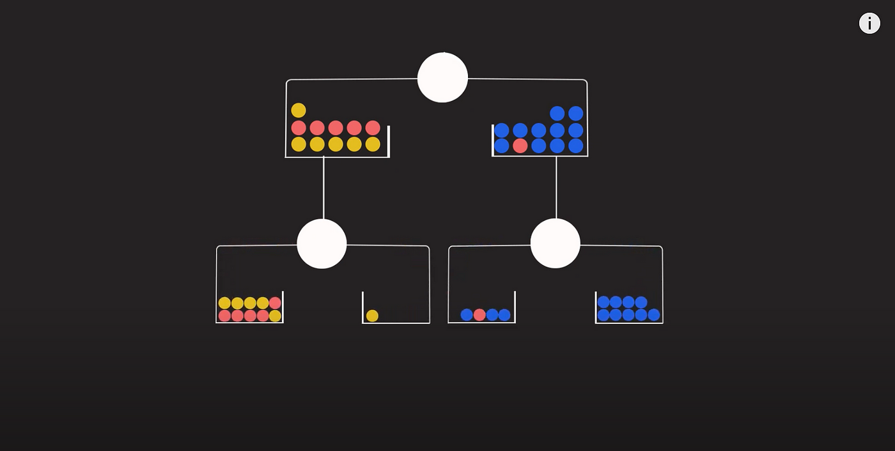

* 1. CONFUSION MATRIX

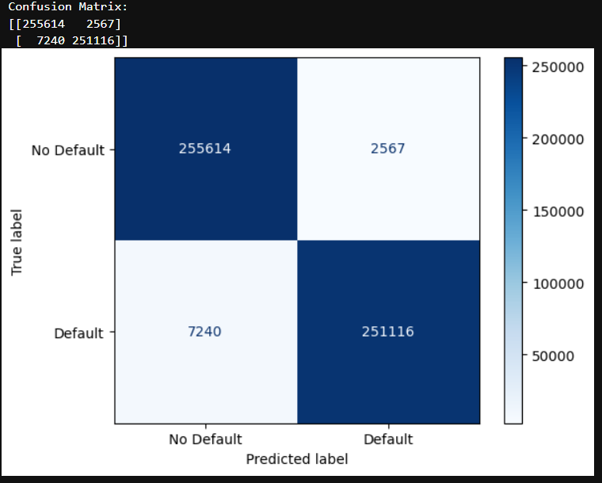

**Goal**: Evaluate the performance of the model.

**Confusion Matrix**: Assess the model’s accuracy, precision, recall, and F1-score.

**Metrics:** Calculate and interpret other metrics such as ROC-AUC for a better understanding of model effectiveness.

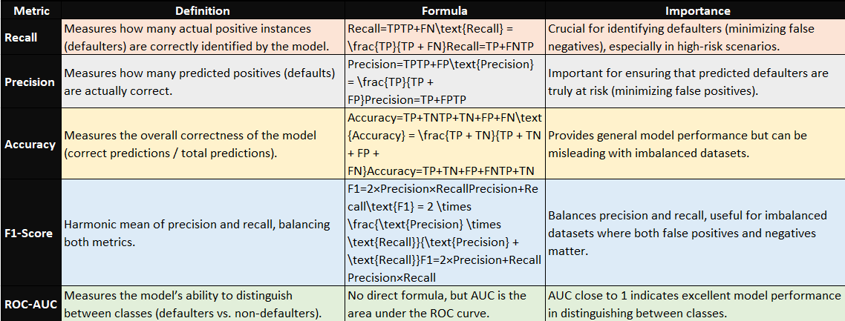

STREAMLIT

